|  |
| --- |
|  |
| The Documentation |
| [Type the document subtitle] |
|  |
| **[Your Name]** |
| **[Pick the date]** |

[Type the abstract of the document here. The abstract is typically a short summary of the contents of the document. Type the abstract of the document here. The abstract is typically a short summary of the contents of the document.]

Table of Contents

[To update the table of contents, right click the message below and select Update Field (F9 on PC, ⌥⌘U on Mac).]

**No table of contents entries found.**

1. Pages
   1. Page Tree

Home  
 Liste des exposants  
 Carte des exposants  
 Intervenants à la table ronde  
 Presse et actualité  
 Commande  
 confirmation

* 1. Home
     1. User Interface

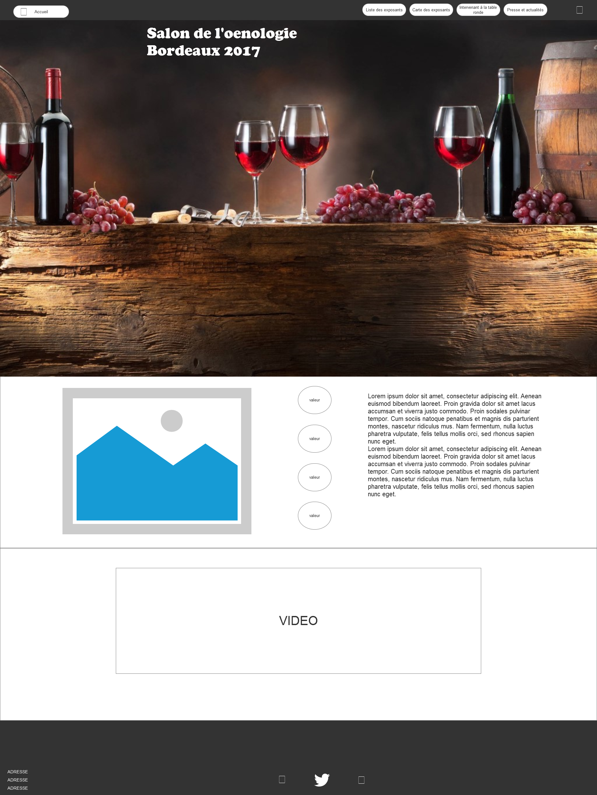

* 1. Liste des exposants
     1. User Interface

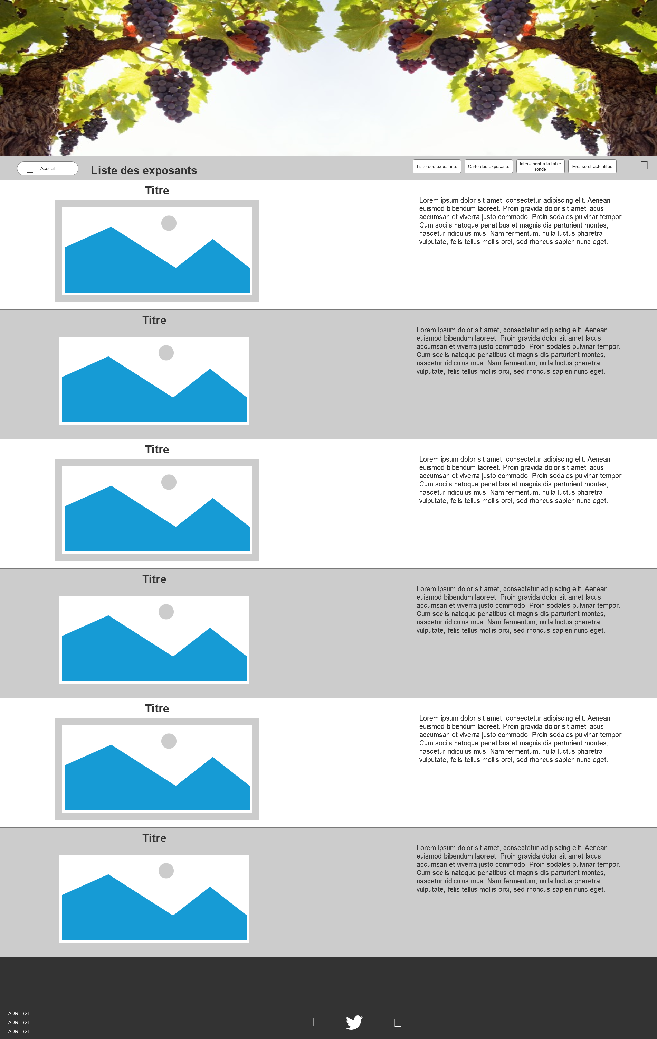

* 1. Carte des exposants
     1. User Interface

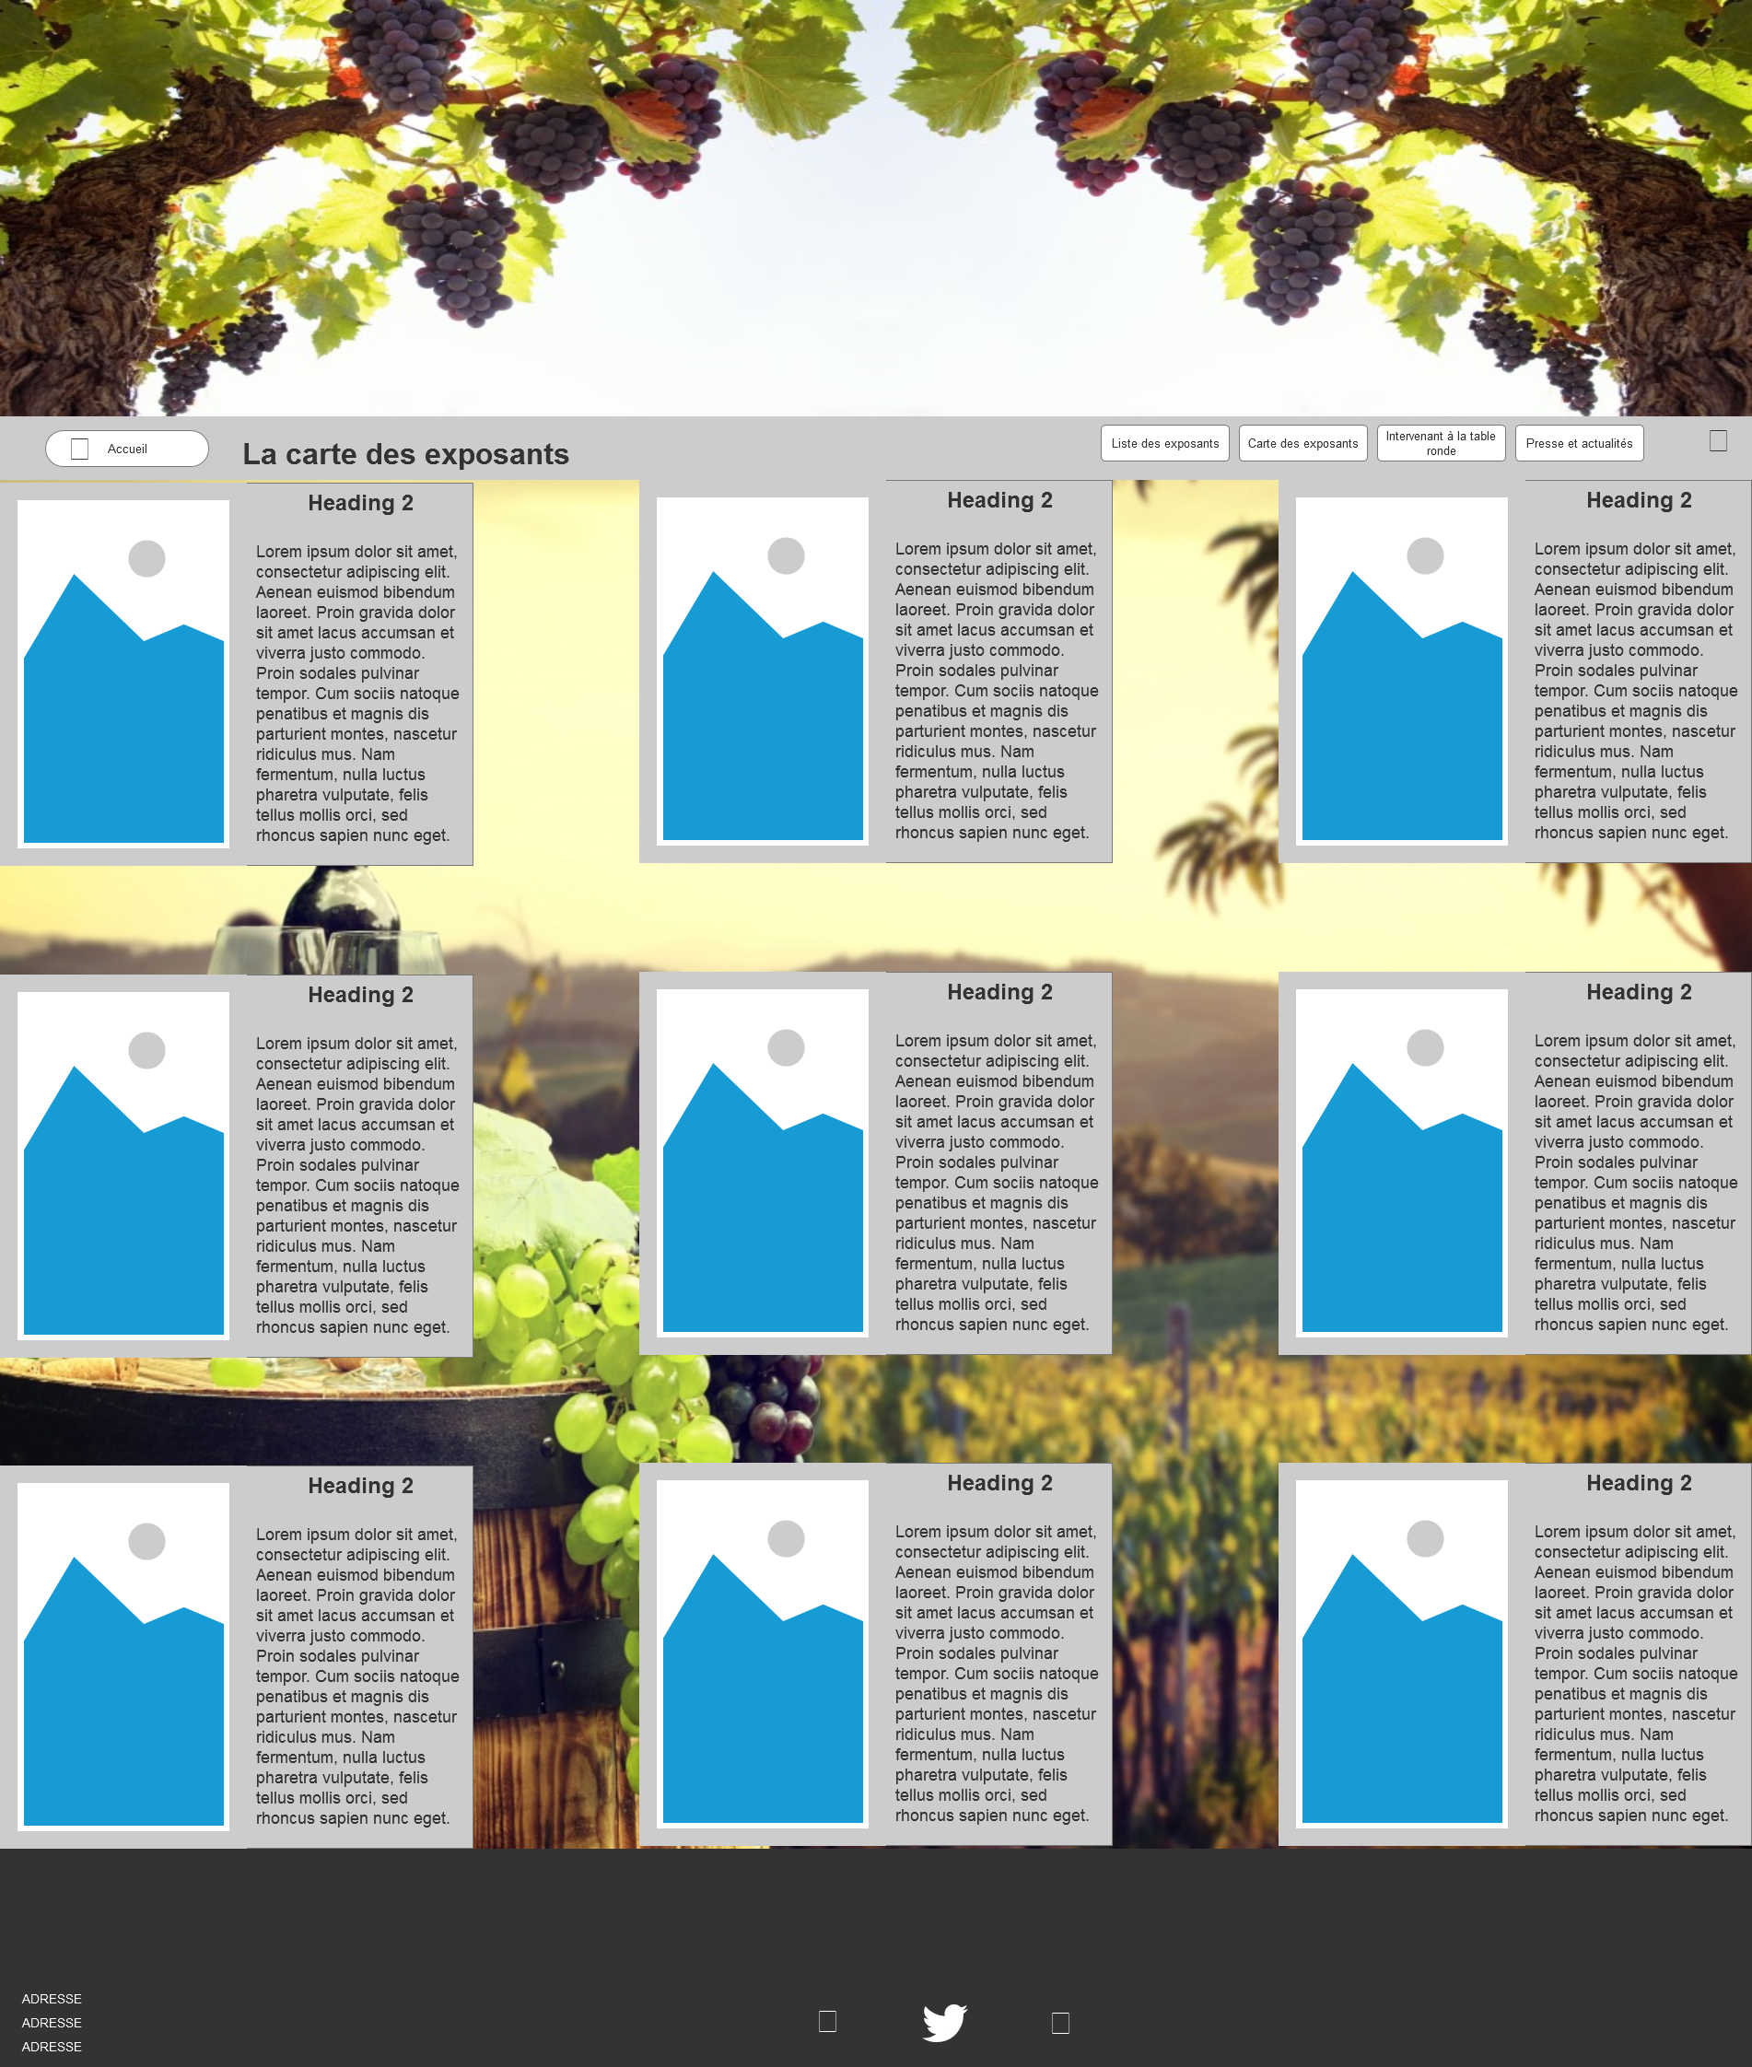

* 1. Intervenants à la table ronde
     1. User Interface

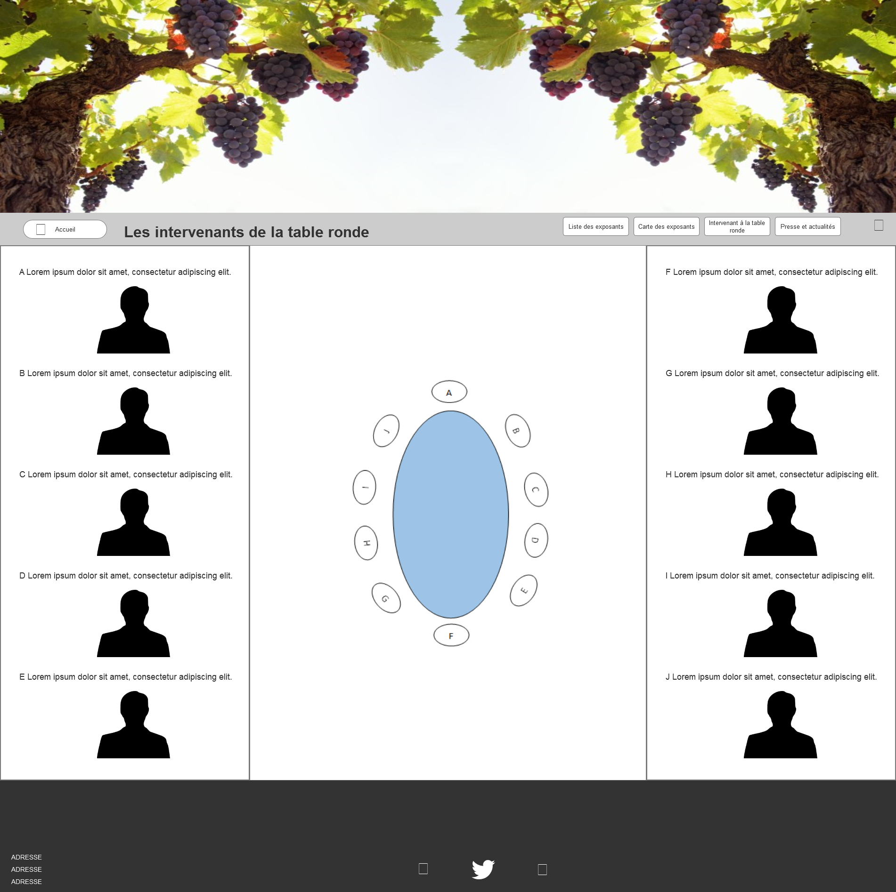

* 1. Presse et actualité
     1. User Interface

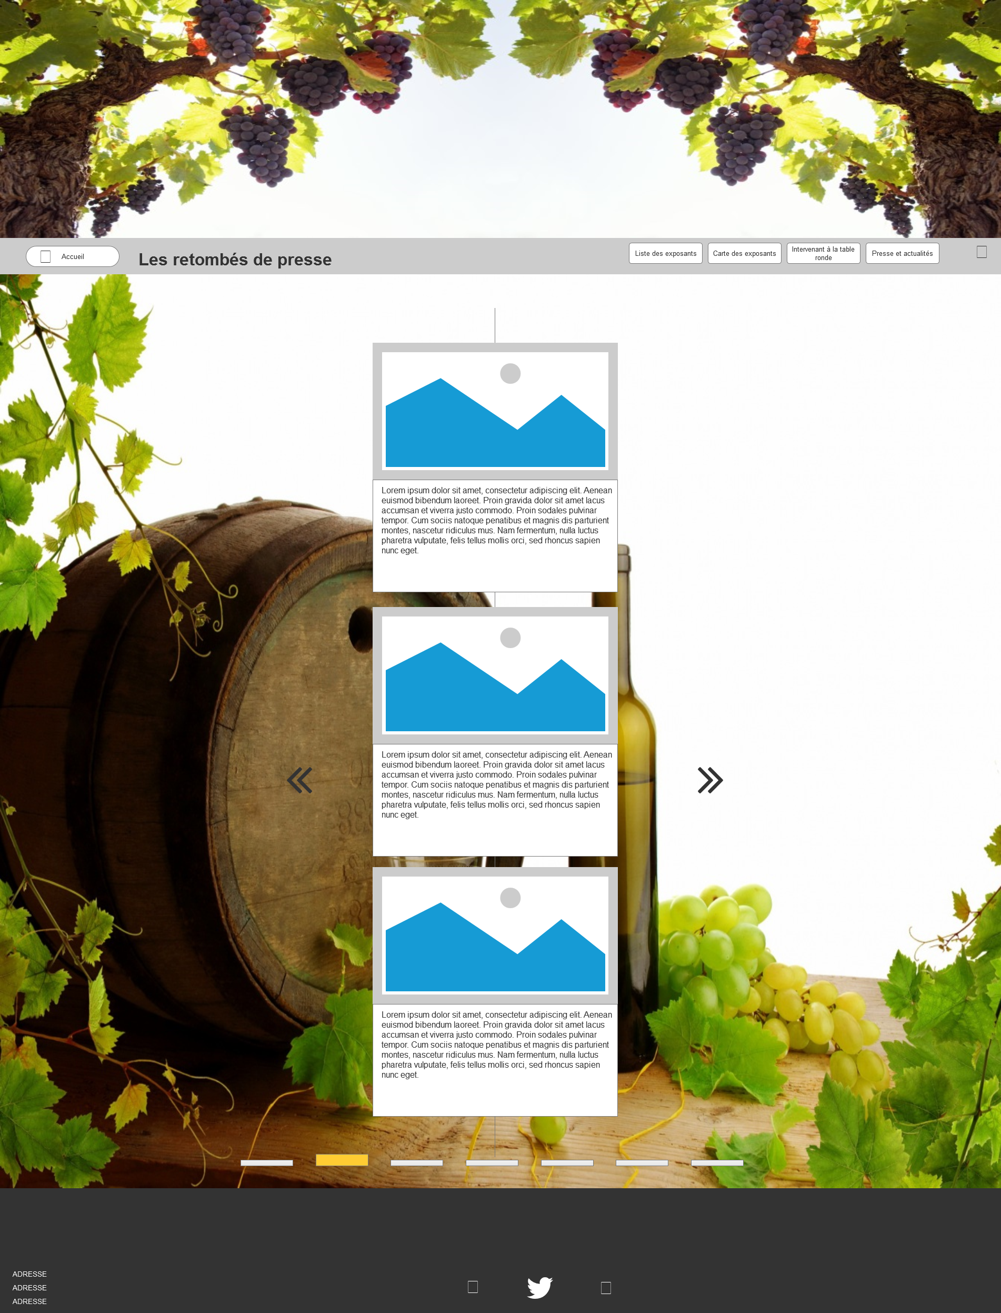

* 1. Commande
     1. User Interface

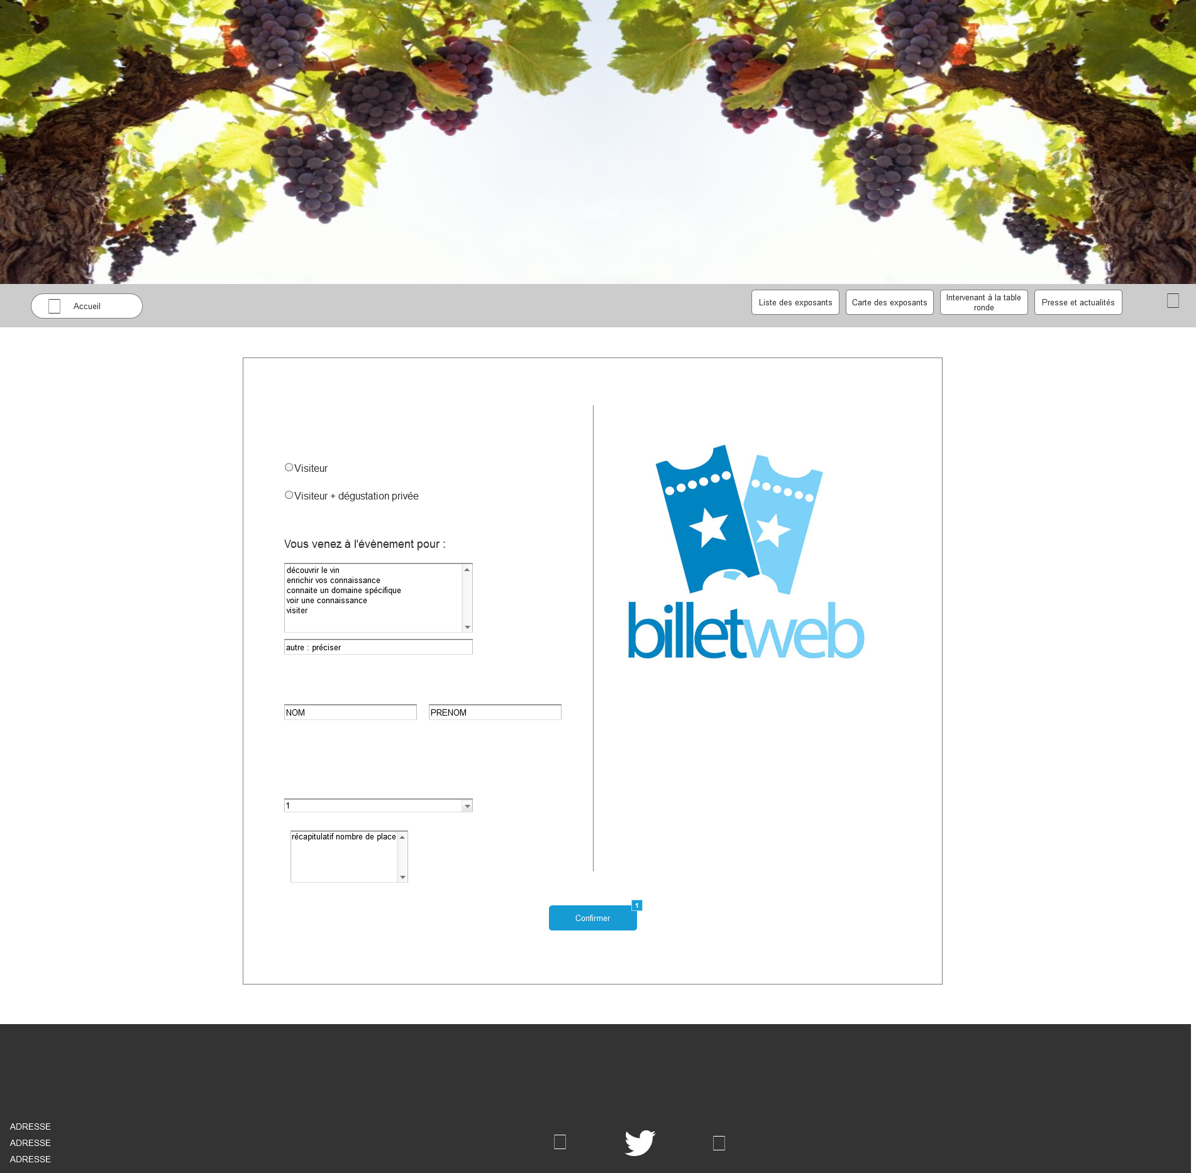

* + 1. Widget Table

| Footnote | Name | Interactions |
| --- | --- | --- |
| 1 |  | OnClick:  Case 1:  Open confirmation in Current Window |

* 1. confirmation
     1. User Interface

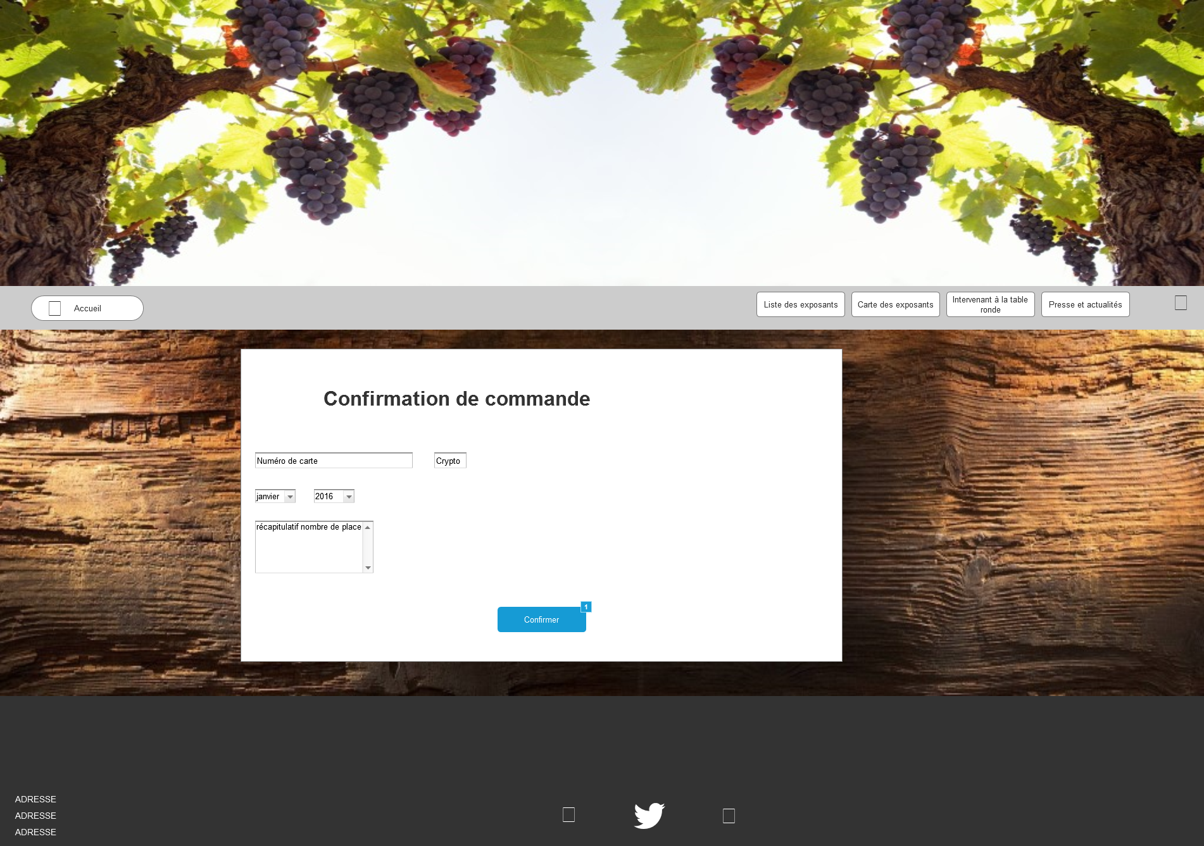

* + 1. Widget Table

| Footnote | Name | Interactions |
| --- | --- | --- |
| 1 |  | OnClick:  Case 1:  Open Home in Current Window |

1. Masters
   1. Master List

header  
header 2  
Contact  
exposant  
carte

* 1. header
     1. User Interface



* + 1. Widget Table

| Footnote | Name | Interactions |
| --- | --- | --- |
| 1 |  | OnClick:  Case 1:  Open Home in Current Window |
| 2 | Liste exposant | OnClick:  Case 1:  Open Liste des exposants in Current Window |
| 3 | intervenantTable | OnClick:  Case 1:  Open Intervenants à la table ronde in Current Window |
| 4 | PresseActualité | OnClick:  Case 1:  Open Presse et actualité in Current Window |
| 5 | commander | OnClick:  Case 1:  Open Commande in Current Window |
| 6 | Liste exposant | OnClick:  Case 1:  Open Carte des exposants in Current Window |
| 7 |  | OnClick:  Case 1:  Open Home in Current Window |

* 1. header 2
     1. User Interface

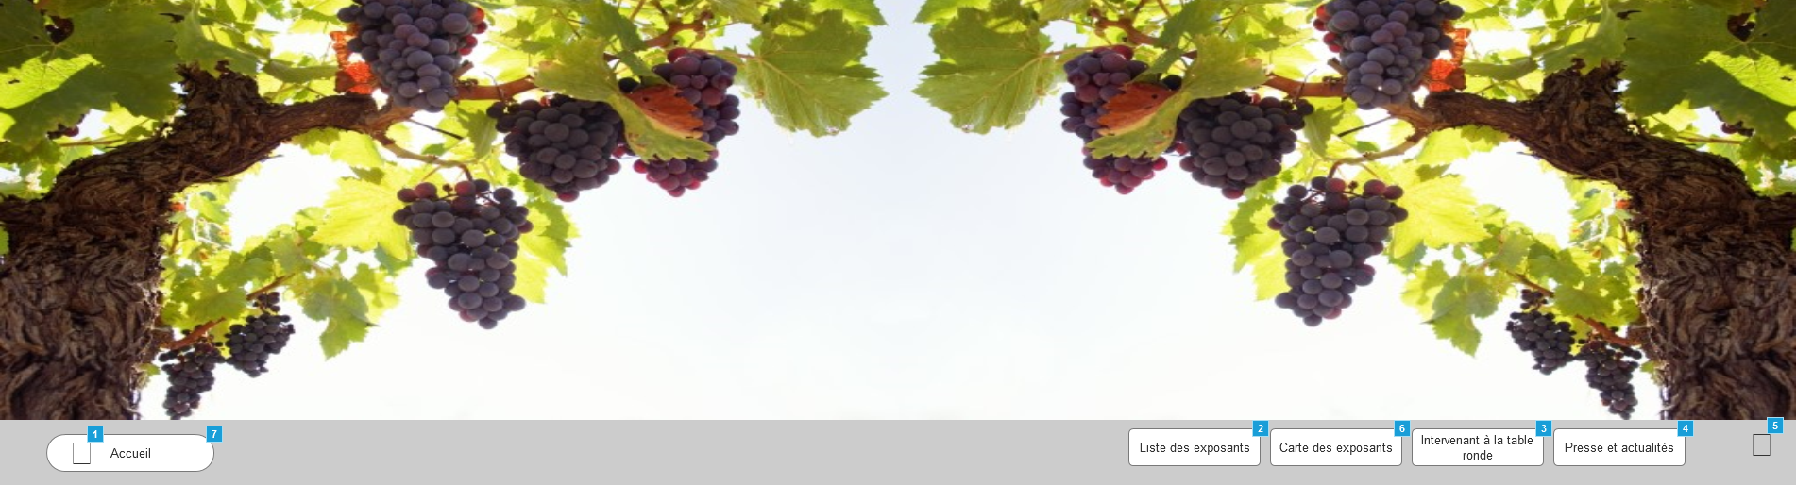

* + 1. Widget Table

| Footnote | Name | Interactions |
| --- | --- | --- |
| 1 |  | OnClick:  Case 1:  Open Home in Current Window |
| 2 | Liste exposant | OnClick:  Case 1:  Open Liste des exposants in Current Window |
| 3 | intervenantTable | OnClick:  Case 1:  Open Intervenants à la table ronde in Current Window |
| 4 | PresseActualité | OnClick:  Case 1:  Open Presse et actualité in Current Window |
| 5 | commander | OnClick:  Case 1:  Open Commande in Current Window |
| 6 | Liste exposant | OnClick:  Case 1:  Open Carte des exposants in Current Window |
| 7 |  | OnClick:  Case 1:  Open Home in Current Window |

* 1. Contact
     1. User Interface



* 1. exposant
     1. User Interface

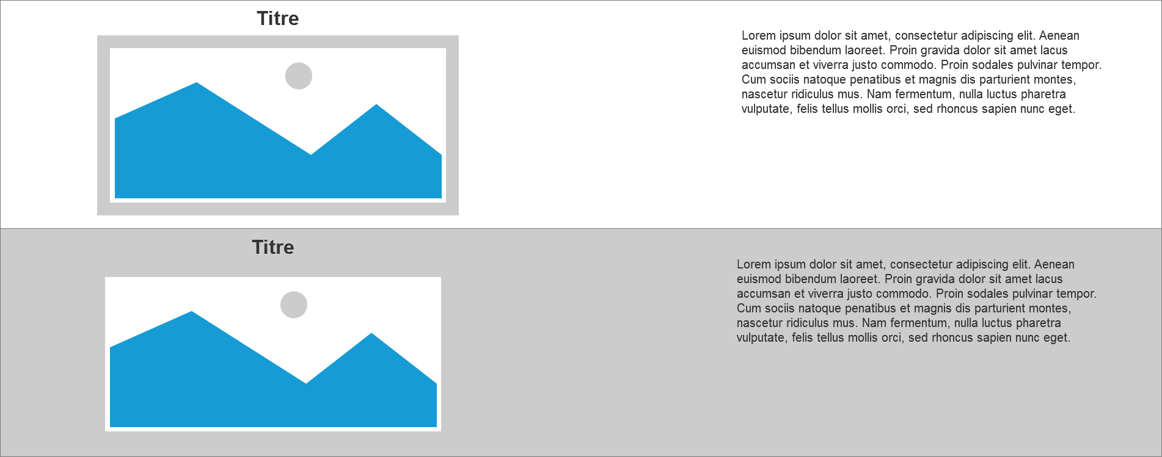

* 1. carte
     1. User Interface

